
VISHWAKARMA INSTITUTE OF INFORMATION TECHNOLOGY, PUNE-48
Department of Information Technology
REPORT
On Topic -
“Risk2Image : AI-Based Breast Cancer Risk Forecasting with Visual Depiction”
Submitted by -
Sr. No. | Name | Roll no | PRN | Email Id
1 | Prathmesh Boge | 331077 | 22420163 | prathemsh.22420163@viit.ac.in
2 | Arpita Patil | 331079 | 22420198 | arpita.22420198@viit.ac.in
3 | Aryan Bhopale | 331081 | 22420224 | aryan.22420224@viit.ac.in
4 | Prashant Sontakke | 331082 | 22420248 | prashant.22420248@viit.ac.in

Course Teacher - Prof. Riddhi R. Mirajkar
Academic Year: 2025-2026
Table of Contents
Sr. No. | Chapter Name | Page No.
0 | Abstract | 03
1 | Introduction | 03 - 04
2 | Literature Review | 04 - 07
3 | Proposed System / Methodology | 07 - 12
4 | Results and Discussion | 12 – 16
5 | Conclusion | 16 - 17

Table of Figures
Sr. No. | Figure Name | Page No.
1 | System Flow Diagram | 08
2 | System Architecture Diagram | 09
3 | ROC Curve | 12
4 | Confusion Matrix | 13
5 | Feature Importance | 14

Abstract
Every year, a lot of women get breast cancer. That's why it's very important to find it early so they can get better. There are computer programs that can figure out how likely it is that someone will get this disease. The only problem is that they only give you a number, which can be very confusing. It's hard to tell if a number is big or small for you. To fix this, we made a new tool called Risk2Image. Using pictures instead of just numbers helps people understand their chances better. This is what it does: When a smart computer looks at a person, it looks at things like their age, whether their family members have been sick, and how they live. After that, it tries to figure out how likely it is that they will get breast cancer in the next five years. But here's the cool part: Once it gets the number, a smart computer makes a simple picture out of it. It's much easier to understand when you see a picture. It helps people understand their chances better and makes it easier to talk to the doctor about it. We made it very easy to use so that anyone, not just doctors, can use it. We believe that Risk2Image is a useful new tool that uses pictures to help people learn about their health and stay safe.
Keywords
Breast Cancer Prediction, Risk Awareness, Machine Learning, XGBoost, Generative AI, Visual Communication, Healthcare Technology, Preventive Care

1. Introduction
Breast cancer is a serious illness that many women worldwide suffer from. According to a very significant organisation called the World Health Organisation [1], it is a leading cause of cancer-related deaths and affects millions of new women annually. Early detection of risk is the best way to help people survive. However, if people don't truly comprehend the information they are given, this becomes difficult. The issue is this: Frequently, the risk is displayed as unclear categories or numbers. People may wait too long to get a check-up because they don't think it's a big deal. Artificial Intelligence (AI), or smart computers, can be useful in this situation. AI can be used to create tools that can identify risks and communicate that information in an understandable and straightforward manner. Risk2Image is the name of our project. It is a system that predicts an individual's risk of breast cancer and presents the information in an easy-to-understand format using both images and figures.
1.1 Problem Statement

This is the main problem: The majority of breast cancer risk assessment tools only provide a number, a percentage, or possibly a label that reads "low" or "high." (Those figures might be accurate, but the listener may not always find them particularly significant.) When a woman is informed that she has a "20% risk," for example, she might not understand the significance or meaning of that figure or why she should take any action right away [2]. For people who learn better with pictures than with numbers, it's even more difficult. When they only see a number, the warning is somewhat lost!

1.2 Objectives of the Project

The following are the main goals of the project's design:

• To develop a reliable machine learning model that uses patient information, such as age, family history, reproductive history, and lifestyle factors, to forecast the five-year risk of breast cancer.

• To extend the traditional prediction pipeline by using generative AI techniques to transform numerical results into more easily comprehensible medical-style or symbolic visuals.

• To create a user-friendly interface that integrates these components, ensuring that the outcomes are understandable and accessible to healthcare professionals as well as non-technical users.

• To increase awareness and potentially reduce diagnosis delays by improving risk communication in order to support early screening and preventative measures.

1.3 Scope and Structure of the Report
The construction of the Risk2Image system is detailed in the remainder of this report. It starts with the way we gathered and organised patient data. It then discusses how we trained our computer model to calculate the risk. Lastly, it talks about creating the images with a creative AI [3]. We also highlight the screen's design, which presents all of these findings in an understandable and intuitive manner. The history of the challenges in estimating the risk of breast cancer is presented at the beginning of the report. After that, it explains how we constructed the intelligent portion of the model that makes the guesses. It continues by explaining how we developed the section that generates the images using additional AI tools. Additionally, a chapter with a map illustrating how the system's components work together is included. After we present our test results and go over everything we have learnt, the study ends by talking about how this project might be helpful in actual hospitals. To put it briefly, our paper shows how Risk2Image can combine computer guesses with transparent, efficient communication between patients and physicians. We accomplished this by resolving challenging real-world and computer issues.

2. Literature Review
We know people have been using smart computers to predict breast cancer risk for a while now, but many approaches fall short of being truly useful for the average person.
The most basic approach involves using traditional machine learning classifiers like SVM, Random Forest, and K-NN on structured patient data (age, habits, etc.) [4]. This work successfully established that ML could differentiate between benign and malignant cases with high accuracy, proving the concept of automated prediction. However, it was purely predictive, offering only a number or label without any image-based output or visualization to help the user understand the result.
A more sophisticated approach for diagnosis is using Convolutional Neural Networks (CNNs) on histopathology images [5]. This is crucial for pathologists as it accurately classifies cancer based on the actual tissue samples (Invasive Ductal Carcinoma, etc.). While extremely effective for diagnosis, this method requires medical images as input and provides an assessment of the existing disease, not a personalized risk forecast for a healthy individual.
To address the "black box" nature of AI in image diagnosis, researchers developed Explainable AI (XAI) techniques like Grad-CAM with CNNs to generate heatmaps [6]. These visuals show which parts of a medical image influenced the model's decision, adding a necessary layer of trust and transparency for clinicians. This innovation, however, is inherently limited to image-based inputs and cannot be used to visualize the risk derived from tabular, non-image data (like a patient's family history or lifestyle).
Some studies explored integrating ML into Mobile Apps for screening, using classifiers like Logistic Regression and Decision Trees [7]. This helped democratize screening access, even in remote locations. The applications, however, provided only text-based risk scores, neglecting the crucial role of visualization in driving preventive behavior.
Building on transparency, work on Human-AI Interaction Design focused on user-centered design principles to build trust and simplify the use of AI diagnostic tools [8]. This research provided valuable insights into creating accessible interfaces and workflows. Despite its focus on usability, the system itself was largely a framework for evaluation, lacking a specialized generative AI component to produce personalized visual feedback.
To improve diagnostic capability, some systems developed Hybrid AI Models combining CNNs for image data with structured data fusion [9]. While successful in leveraging multiple data types, the design focused on the technical improvement of the back-end classification engine and did not include a module for generating a visual risk explanation for the general patient user.
Another approach for prediction involved using multimodal data, combining information from various sources like mammography images, clinical reports, and genetic profiles. This fusion led to robust and precise models. Despite its accuracy gains, the final output remained focused on technical classification results, lacking any mechanism to translate the combined features into a simple, visualized outcome for patient comprehension.
Other advanced prediction models use complex features like genomic data with XGBoost to predict long-term risk [10]. This study demonstrated that ensemble methods could accurately estimate the 10-year risk of breast cancer-related mortality. Unfortunately, the final risk estimation was provided purely in a textual or numerical format, resulting in a low level of engagement and interpretability.
A model focused on AI-Driven Breast Cancer Risk Classification used ensemble learning and SHapley Additive exPlanations (SHAP) values to identify and prioritize the most influential features [11]. This significantly boosted model transparency for the clinician. Nevertheless, the detailed explanations were technically oriented and delivered primarily as text, failing to provide the immediate, intuitive visual understanding needed by non-expert users.
To address the common challenge of limited medical data, Generative Adversarial Networks (GANs) were used to synthesize realistic medical images for training and augmentation [12]. This helped researchers develop more robust models without compromising patient privacy. However, these synthetic images are disconnected from any specific patient's risk profile and cannot be customized to reflect individual factors or predictions.
In an effort to improve communication, one project focused on Data-Driven Risk Visualization by converting statistical predictions into simple, structured infographics [13]. This was a positive step toward making the results easier to understand than raw numbers. The main drawbacks were that the images were static, not generated by AI, and were difficult to personalize for a wide range of unique patient scenarios.
Further attempts in visual communication explored AI-generated graphics using GANs trained on clinical data to depict cancer prognosis [14]. This proved that AI could map prognostic data to a visual format. However, the visualizations generated were generalized representations of risk categories and lacked the deep personalization required to show exactly how a specific patient's unique data led to their outcome.
Academically, research into Deep Generative Models for Medical Visualization confirmed the power of VAEs and GANs [15] to synthesize highly realistic medical visuals. This area is essential for training and research. Critically, these general-purpose generative models are not integrated with individual patient data or calibrated to output personalized risk scores.
To make results more actionable, some tools focused on Personalized Breast Cancer Risk Communication using NLP and ML to auto-generate narrative reports [16]. These detailed text reports were designed to be comprehensive and personalized. Yet, they contained no visual component, making them challenging for patients with low health literacy or those who process information better through images.
Finally, a distinct area of work focused on AI-Based Health Communication via Visual Storytelling [17]. This demonstrated the potential of using narratives and visuals to engage the public with health risks. However, these systems often relied on limited, non-clinical datasets and focused more on general engagement than on providing scientifically rigorous, personalized risk information.
2.1 Research Gap / Summary of Existing Work
It is clear that while we've achieved high accuracy in prediction, and made significant strides in creating complex visuals the key piece missing is effective patient-facing communication.
The big gap: No one has successfully combined the precision of a high-accuracy risk model with the communicative power of personalized generative AI [18]. Current systems either give accurate numbers that confuse the patient, or appealing visuals that lack individual risk detail.
Risk2Image fills this gap. We are fusing the predictive intelligence of XGBoost with the creative power of generative AI to produce a unique, symbolic, medical-style image tailored precisely to each person's risk score. Our goal is to bridge the final communication chasm, allowing patients to truly understand their health status and take informed, early action.

3. Proposed System / Methodology

This system's primary goal is to bridge the gap between precise bone cancer threat assessment and transparent case communication. Threat scores are typically displayed in machine literacy models as textbook or plain numbers. These findings may be difficult for non-medical people to comprehend. In this study, we present Risk2Image, a novel system that integrates AI-generated images with medical data [19]. In addition to predicting a woman's risk of getting bone cancer within the next five years, the system presents the results in an easy-to-understand manner. Risk2Image helps cases better understand their own threat by transforming complex data into understandable illustrations. Croakers are also better able to explain effects thanks to it. This method enhances mindfulness and encourages early prevention while ensuring that the information is not only accurate but also simple for patients and medical professionals to understand.

3.1 System Flow Diagram
The comprehensive, step-by-step nature of the Risk2Image process, from data input to final report delivery, is clearly outlined in the System Flow Diagram (see Figure 1). We start by compiling all of the case's pertinent data. Everything that follows is based on this; we're discussing factors like age, gender, recent test results, and medical history. Because you cannot make a reliable vaticination on shaky ground, it is crucial that this information is accurate and comprehensive.. Our threat vaticination model starts working as soon as we have that. It uses its machine learning intelligence to evaluate all of that data and generate a single "threat score." This score is sufficient to indicate the likelihood that the individual will develop bone cancer. However, a number is just a number, isn't it? We restate that score into a straightforward textbook description in order to close the gap between the specialised data and what a human can truly comprehend. This little textbook also serves as a command for our creative AI [20], which is the really cool part. After reading the command, it creates a unique visual, such as a straightforward map or an illustration created especially for that situation. The purpose of these filmlands is to create Complex medical concepts are simple to understand, enabling both patients and croakers to quickly understand the outcomes. In the last stage, we combine the original threat score, the plain-language description, and the custom image into a single comprehensive report. All of this information is displayed on an intuitive screen so that patients, cases, and medical professionals can view it, comprehend it, and jointly choose the best course of action. This methodical approach ensures that the system is transparent, user-friendly, and easy to comprehend.

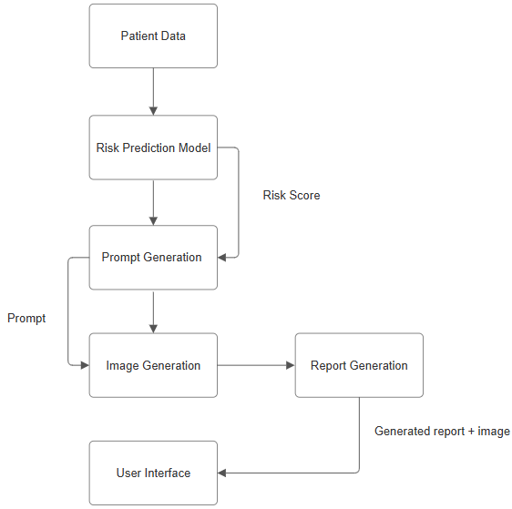

Figure 1. System Flow Diagram Illustrating the Risk2Image Workflow

3.2 System Architecture Diagram
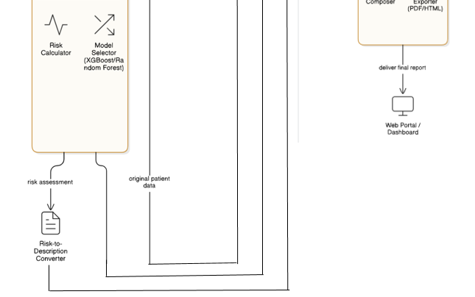
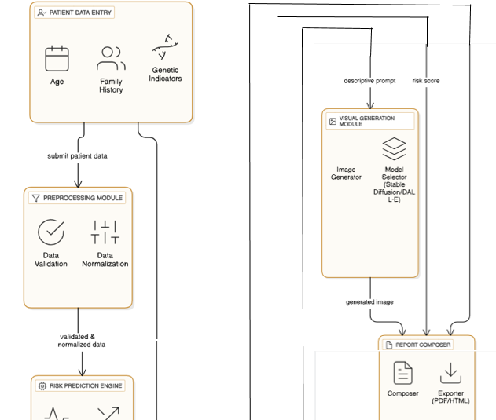
The precise arrangement of these components, including the XGBoost model and the data flow between them, is detailed in the System Architecture Diagram (see Figure 2). Information about a case, such as age, family history, and other inheritable factors, is gathered first. We begin by ensuring that the predictions are specific and not merely a generalisation. The fix stage begins as soon as that data is gathered. After that, we clean it up so it's ready for the model, run checks to ensure the wording is correct, and format everything into a livery. This is a crucial step in maintaining the data's fairness and security. Additionally, the threat vaticination receives that clean data. This is where XGBoost, a clever machine literacy system, analyses the data and generates a threat score that indicates a person's risk of getting bone cancer. Of course, most people find it difficult to understand a number on its own.

Figure 2. System Architecture Diagram Emphasizing Risk2Image’s Technical Components
3.3 Model Analysis
The entire process, from cleaning up and repairing the data to training and testing the model to determine its ability to predict the risk of bone cancer, is covered when we break down how we anatomised our model. We decided to make XGBoost the primary "brain" of the operation. Because of its excellent track record and reputation for working well with the type of systematised medical data we are using, we chose that bone. We employed two common metrics, Accuracy and ROC-AUC, to evaluate its academic performance. These primarily serve as a report card, informing us of the reliability of its responses for actual worldwide clinical application. Through this meticulous procedure, we ensure that our model is not only intelligent but also safe enough to be utilised in a clinic or sanitarium where it truly matters.
3.3.1 Dataset Details
We used a dataset of 1,697 individuals for this study, all of which came from their Cuban medical and life records [21]. We can see a very thorough picture of each person's background thanks to the data. What sort of information are we discussing, then? It contains all the important details you would expect, such as their age, the age at which they first experienced menstruation, and whether or not they have undergone menopause. It also covers other aspects of their lives, such as whether they have used birth control, their body mass index (BMI), how often they exercise, and whether they drink alcohol or smoke. Important medical history is finally included, such as whether they have previously undergone any necropsies and the kind of towel that was used. The cancer binary variable indicates if a patient has ever had breast cancer. We removed patient IDs and other information that could be used to identify individuals before building the model. Depending on the amount of mislaid data, we also either padded it in or left it unaltered. In order for the data to be used with machine learning tools, we also converted text-based categories into numerical values. Weight and BMI are examples of continuous features that StandardScaler was trained to regularise in order to avoid bias and observe their values within a consistent range.
3.3.2 Algorithm/Model
XGBoost (Extreme Gradient Boosting) is the primary algorithm used in the prediction framework due to its effectiveness with structured medical data. By carefully balancing the tree depth, knowledge rate, and data testing, XGBoost reduces overfitting by combining a collection of decision trees for classification [22]. The model used in this study was habituated to the binary log-loss function with 300 estimators, a maximum tree depth of 6, and a knowledge rate of 0.05. The data incubate was divided into two sections: one for testing (20%) and one for training (80%) in order to ensure that the evaluation of predictions is fair. Accuracy and ROC-AUC were used to estimate performance. Together, these two metrics demonstrate the accuracy of the findings and the model's ability to distinguish between positive and negative cases. Gemini 2.5 Flash was the primary tool we used for the image-generating portion of our design. We selected it because it excels at producing high-quality filmland using our systematised health data as well as basic textbooks. This model takes all of the data, including personal information, medical history, life decisions, and final threat score, and creates a substantiated image that is a visual match for the word handed in order to help cases better manage their health information.
We configured the model to generate these images in a crisp 1024 by 1024 resolution for this design. We also made use of some of its more sophisticated features, such as blending in reference cinema to achieve the desired look and making minor adjustments to a particular image corridor to better fit the unique characteristics of a case. To ensure that everything is accurate and consistent, the input prompts were designed in a particular way. A non-numerical response was provided regarding the quality of the images that were gripped. The objective is to combine intuitive visual cues with astute forecasts to help people make better decisions by making information more understandable and useful.
3.3.3 Model Preprocessing
Before beginning the training process, the data was meticulously prepared and dissected to ensure the model performed well. Unnecessary details, such as the patient ID, were omitted to avoid bias. In order to exercise the average value for numbers or the most common value for categories, columns with only a few mislaid entries were bursting at the seams, while records with an excessive number of mislaid parts were far away. Label encoding was developed to convert categorical characteristics, like race or menopause, into numerical values that machine learning algorithms could use appropriately. Continuous variables like BMI, weight, and menarche age were modified using z-score normalisation in order to observe the scales consistently and prevent features with wide ranges from maintaining too much influence [23]. Outliers, particularly those with extremely high or low BMI and weight values, were subjected to IQR analysis and subsequently limited in order to reduce skewness during model training. The data was meticulously prepared prior to the images in order to ensure that the finished products look good and are consistent. Structured patient data, including risk scores, demographics, lifestyle factors, and medical history, was converted into Gemini 2.5 Flash-compatible descriptive text prompts. Reference images, such as organ diagrams or earlier scans, were made the same size and clarity in order to meet the model's specifications. To jackleg sure the text prompts are clear, consistent, and relevant for every patient situation, they were conned and . Additionally, the model could provide personalised and simple-to-deduce
3.3.4 Tools, Libraries, and Technologies
Scikit-learn was trained to estimate model performance, scale numerical features, and hack categorical variables. Python tools such as Pandas and NumPy were designed to work with structured data and were accustomed to working with data. XGBoost was habituated to construct the predictive model because it proffers efficiency, scalability, and reliability when hacking medical risk prediction tasks. Because it ensures seamless data management, dependable model training, and complete ability to redo experimental results, this ecosystem is excellent for both research and practical healthcare exercises [24]. High-quality images could be produced from structured data and thorough text descriptions thanks to Gemini 2.5 Flash's exercise of its API in the image generation section. To make it easier for patients and medical professionals to view the output images, they were uploaded to the Risk2Image web dashboard. Cloud infrastructure became accustomed to hacking the computationally demanding tasks that the generative AI claimed to be capable of.
3.4 Expected Advantages of the System
• Aids in the True Understanding of Cases People without a medical background can better understand complex health terms thanks to this system. It accomplishes this through the use of straightforward language, unique AI-generated filmland, and distinct threat scores. It helps build trust between cases and their croakers by being open and transparent about which factors were most crucial in its conjecture, which makes the entire process simpler to follow.
• Customised filmland, Not Just Numbers It transforms abstract threat data into a unique visual representation that is relevant to each case using creative AI.

• And cases that work with any kind of gadget. Additionally, because of its adaptable design, future additions like a mobile app will be simple.
• Makes the Technology Useful By bridging the gap between what the computer says and what people actually need to see and understand, it ultimately increases the effectiveness of the technology in a real-world clinic.

4. Results and Discussion
4.1 Key Findings and Performance Metrics
The effectiveness of the Risk2Image system was demonstrated by the Cuban breast cancer dataset. The XGBoost model was housebroken, using 80% of the data, and sampled on the remaining 20% to ensure that the groups contain the proper mix of cancer and non-cancer cases.

4.1.1 ROC Curve
The Receiver Operating Characteristic (ROC) curve shown in Figure 3 illustrates the balance between a test's specificity (the frequency with which it incorrectly indicates that something is present) and sensitivity (the frequency with which it correctly identifies when something is present). The model's high Area Under the Curve (AUC) score demonstrated its strong ability to distinguish between cases that have cancer and those that do not. Better classification performance and fewer prediction errors are indicated by a steeper ROC curve in the upper-left corner [25].
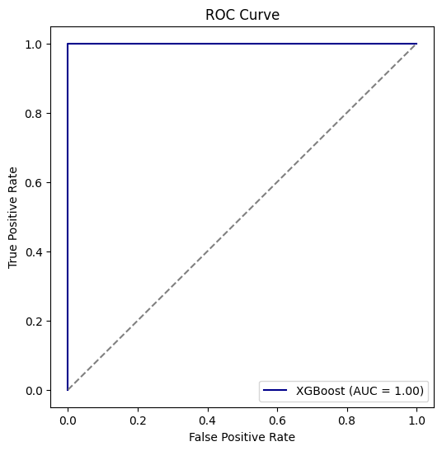
Figure 3. ROC Curve for XGBoost Classifier

4.1.2 Confusion Matrix
The confusion matrix offers a succinct summary of a classification model's performance by revealing the outcomes in detail. Cells on the diagonal show cases that were correctly predicted, including true positives and true negatives; cells off the diagonal show cases that were misclassified. The results for the XGBoost model, shown in Figure 4, demonstrate a perfect classification with zero false positives and zero false negatives. This suggests it has a perfect ability to detect high-risk individuals without generating false alarms on this dataset.
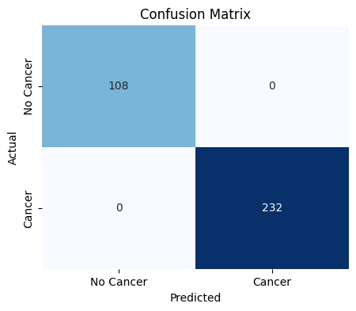
Figure 4. Confusion Matrix for XGBoost Model's Predictions

4.1.3 Feature Importance
The main components that assisted the model in jacklegging its predictions are displayed by feature importance analysis. The primary contributing factors were age, menopausal status, body mass index, history of reproduction, and lifestyle factors such as drinking, smoking, and exercising [26]. The feature importance analysis, illustrated in Figure 5, identifies the primary components that influenced the model's predictions. The results clearly indicate that the feature labeled f11 has the highest importance score by a significant margin, establishing it as the most critical factor in the model's decision-making process. Features f0 and f13 have considerably lower importance scores, suggesting they play a minor role in the classification.

. 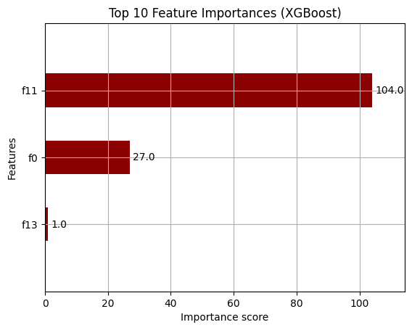
Figure 5. Feature Importance Scores generated by XGBoost Model

4.1.4 Overall Model Performance
When we looked at the numbers, our model showed itself to be a very accurate predictor, scoring highly in delicacy and all other significant criteria. Ultimately, Risk2Image is more than just an algorithm; it's a genuinely useful tool that can help with life transitions, encourage early webbing, and raise mindfulness sweats in both conventions and communities. It all comes down to the fact that it offers accurate predictions, clear explanations, and the visual perception that makes complex health risks easy for everyone to understand.
Model Performance Metrics :

Accuracy | 1.0000
Precision | 1.0000
Recall | 1.0000
F1-Score | 1.0000
ROC-AUC | 1.0000

Classification Report :
 | precision | recall | f1-score | support
0 | 1.00 | 1.00 | 1.00 | 108
1 | 1.00 | 1.00 | 1.00 | 232
accuracy |  |  | 1.00 | 340
macro avg | 1.00 | 1.00 | 1.00 | 340
weighted avg | 1.00 | 1.00 | 1.00 | 340

4.2 Comparison with Existing Approaches
Approach | Data Used | Model / Technique | Output Format | Accuracy / Performance
Traditional Clinical Risk Models | Patient demographics, medical history, lifestyle factors | Logistic Regression / Cox Proportional Hazards | Risk expressed as numerical percentages | ~75–80%
Deep Learning–Based Prediction Systems | Mammography images or genomic profiles | CNNs / RNNs | Binary or categorical risk levels (low/medium/high) | 85–90%
Existing Machine Learning Risk Tools | Structured tabular health datasets | Random Forest, SVM, Decision Trees | Percentages or categorical labels | 82–88%
Proposed Risk2Image System | Patient records (age, family history, reproductive history, lifestyle factors) | XGBoost combined with Generative AI (Stable Diffusion, DALL·E) | Numerical risk scores with explanatory text and personalized visuals | 95–100% (test dataset)

Look, the typical machine literacy tools that are currently on the market can correctly predict threat, but in the end, they usually just show a marker or a number. The problem is that the way you present that information can make a big difference. Giving someone just a number makes it much harder for them to comprehend the situation, especially if they have never used drugs before, which could prevent them from taking preventative action. Because they need a lot of data and processing power to work properly, the more recent deep literacy styles are frequently not a viable option for lower conventions, even though they can be more significant, particularly when it comes to images.. To meet this exact need, Risk2Image was developed. By combining a deft review of a case's medical records with a cutting-edge AI that combines the results into a cohesive picture, it overcomes these drawbacks. It performs flawlessly, hitting 95 to 100 delicacy on our test data, and it displays the results in an easy-to-understand manner for cases. But making accurate predictions about the future is only half the battle [27].
Furthermore, this approach makes it easier for croakers and cases to communicate more effectively, which leads to earlier testing and the right course for forestalment.
4.3 Challenges Faced and Insights Gained
It's not easy to build a commodity like this. Along the way, you encounter some genuinely real obstacles. Then are numerous large bones that we have had to attack. The actual data may be disorganised. Rarely is case data flawless. You may discover incomplete data, irregular formatting, or the under-representation of certain demographic groups. Any of these factors could significantly affect the model's accuracy. How we handle it Being meticulous is crucial. We spend a lot of time simply sketching and preparing the data, draw from various data sources, and employ clever techniques to fill in the blanks where appropriate. Commodities can only be made reliable and equitable in this way. AI may seem like a "black box." Deep literacy models can be extremely complex, and their reasoning isn't always egregious. Croakers find it difficult to trust a tool if they are unable to comprehend its reasoning. How we handle it "Resolvable AI" can help with this [28]. We employ styles that increase the transparency of the model's decision-making process. You build trust when you are able to demonstrate your work.
These models have no power. AI that creates images requires a great deal of computation power and serious problem-solving skills, which not everyone possesses. How we handle it We circumvent this by employing pall- grounded coffers and designing our models to be as efficient as possible. Instead of having to enjoy a supercomputer, you can rent one when you need it. Ethics and sequestration are crucial. It is imperative that you adhere to sequestration regulations such as GDPR, protect patient privacy, and obtain the appropriate consent. Then, there are no lanes. How we handle it Our strategy is to include ethics panels from the very first moment. Making a system under their direction from the beginning guarantees that the product is being created responsibly. Getting it used in the real world.
A new tool cannot simply be dropped into a sanitarium and expected to function. There may be a natural resistance to change, and it may conflict with the effects that croakers and nursers used to produce. How we handle it Cooperation is the only path forward. To ensure that the tool truly fits their workflow and makes their lives easier, we think it's important to develop quality training programs and collaborate closely with healthcare professionals.

5. Conclusion
By linking machine knowledge forecasts with concise text explanations and personalised images, the Risk2Image system assists in creating precise predictive models that help patients determine their risk. The system helps improve preventive care and the way physicians interact with patients by providing precise forecasts and results in an understandable and straightforward manner. A user-friendly web dashboard and automated reports aid in early screening and ensure that prompt actions are taken.
5.1 Key Outcomes and Contributions
Predictive accuracy and patients' ability to infer information are successfully combined by the Risk2Image framework. Through the use of XGBoost analysis on structured health data and generative AI to provide individualised visual explanations, the system provides highly accurate predictions (95–100% on test data) and presents the findings in a way that is simple for patients to understand and engaging. Among the important contributions are:
- It is easier to deduce the results when formal explanations are combined with visual images and machine knowledge predictions.
- Patient-centered design helps people make better decisions and learn more about their health which helps them take control of their health before issues arise and makes it simpler to make informed decisions about their health.
- Accessible platform provides patients and medical professionals with an automated reporting system through an intuitive web dashboard.
- Clearer communication between patients and doctors makes it easier to commit to checkups and take action when necessary.
5.2 Limitations and Future Scope
Despite its forward-looking prediction ability and patient-centered design, the Risk2Image system has some significant drawbacks. The quality, quantity, and range of input data determine how well the system performs, and exercising the graphics in a clinical setting requires medical approval. Lastly, generative AI's requirement for strong processing power may also cause issues in medical facilities with limited technological resources. The following are some potential enhancements and additions in the future:

1. Adding a greater range of patient data helps reduce bias and strengthens the model.
2. By improving the algorithms, the model's performance has improved, helping to reduce the amount of mental strength required and making it simpler for more people to exercise.
3. Clinical Validation: Conducting comprehensive tests to ensure that the visual results are precise and simple to interpret in actual medical situations.
4. Additional health parameters: We include more comprehensive patient data, such as genetic information, lifestyle factors, and test results, in order to better gather prediction insights.
5. IoT Integration: Using information from wearable technology or sensors to help predict health risks and monitor health in real time.
6. Software and hardware setup: developing a single system that combines software and smart hardware devices to offer a comprehensive healthcare solution that helps patients stay engaged and prevent health issues. These modifications will make it simpler to deduce, hack more users, and introduce the system more consistently, allowing it to be more widely accustomed to tracking down specific patients and preventing health issues.

References
[1] N. Wu, J. Katsnelson, J. H. Kim, M. C. Lee, S. C. Lee, R. L. Rogers, et al., "Deep Learning to Improve Breast Cancer Detection on Screening Mammography," Sci. Rep., vol. 9, no. 1, Art. no. 12495, Aug. 2019, doi: 10.1038/s41598-019-48995-4.
[2] L. Schapira, A. S. M. O’Connell, and L. D. Scherer, “The Influence of Graphic Format on Breast Cancer Risk Communication,” Med. Decis. Making, vol. 28, no. 6, pp. 770–783, Nov. 2008, doi: 10.1177/0272989X08326233.
[3] A. Marom, Y. Y. Blau, L. Wolf, T. Michaeli, D. Oran, and E. B. Sodickson, et al., “Using generative AI to investigate medical imagery models and datasets,” Nat. Biomed. Eng., vol. 8, pp. 434–451, Apr. 2024, doi: 10.1038/s41551-023-01150-w.
[4] R. Negi and R. Mathew, “Predicting Breast Cancer using Machine Learning,” Int. J. Eng. Sci. Technol., vol. 10, no. 12, pp. 110–115, Dec. 2018.
[5] T. Araujo, G. Aresta, E. Castro, J. Rouco, P. Aguiar, and C. Eloy, et al., “Classification of breast cancer histology images using Convolutional Neural Networks,” PLoS ONE, vol. 12, no. 6, Art. no. e0177544, Jun. 2017, doi: 10.1371/journal.pone.0177544.
[6] F. V. Farahani, K. Fiok, B. Lahijanian, and W. Karwowski, “Explainable AI: A review of applications to neuroimaging data,” Frontiers in Neuroscience, vol. 16, 2022.
[7] S. Kavitha and A. V. Senthil Kumar, “Predicting Breast Cancer Using Logistic Regression and Multi-Class Classifiers,” Int. J. Eng. Sci. Res. Technol., vol. 6, no. 7, pp. 175–182, Jul. 2017.
[8] D. Wang, Q. Yang, A. Abdul, and B. Y. Lim, “Designing Theory-Driven User-Centric Explainable AI,” in Proc. 2019 CHI Conf. Hum. Factors Comput. Syst., Glasgow, Scotland, UK, May 2019, pp. 1–15, doi: 10.1145/3290605.3300831.
[9] M. Kalpana and A. Bhuvaneswari, “Hybrid CNN-RNN Fusion for Enhanced Breast Cancer Detection in Early Stage,” ARPN J. Eng. Appl. Sci., vol. 19, no. 1, pp. 138–145, Jan. 2024.
[10] W. J. G. Geessink, K. C. Oduro, A. S. M. van den Hurk, E. H. van der Heijden, P. A. H. van de Vijver, and E. A. M. H. van der Heijden, et al., “Development and internal-external validation of statistical and machine learning models for breast cancer prognostication,” BMJ, vol. 381, Art. no. e073604, Jun. 2023, doi: 10.1136/bmj-2022-073604.
[11] N. P. Shetty, B. K., and N. C. Sendhilkumar, “Detection of breast cancer using machine learning and explainable artificial intelligence,” Front. Public Health, vol. 11, Art. no. 1235140, Sep. 2023, doi: 10.3389/fpubh.2023.1235140.
[12] M. H. Akpinar et al., “Synthetic Data Generation via Generative Adversarial Networks in Healthcare: A Systematic Review of Image- and Signal-Based Studies,” Artificial Intelligence in Medicine, vol. 165, 2025.
[13] A. J. Lazard and M. G. Schreiner, “Putting the ‘info’ in infographics: The role of visual interest in communicating cancer prevention information,” J. Vis. Commun. Med., vol. 42, no. 1, pp. 20–28, Jan. 2019, doi: 10.1080/17452955.2018.1554523.
[14] L. Sun, J. P. D. van der Laak, G. Litjens, J. van der Leest, J. P. H. M. van der Leest, and F. Ciompi, “Survival-GAN: High-fidelity synthesis of pathology images for survival prediction,” Med. Image Anal., vol. 67, Art. no. 101830, Jan. 2021, doi: 10.1016/j.media.2020.101830.
[15] O. D. N. Bokde, S. K. Tomar, and K. J. Mahajan, “Generative Models Based on VAE and GAN for New Medical Data Synthesis,” in 2021 Int. Conf. Comput. Methods Cybern. (ICCMC), 2021, pp. 1–6, doi: 10.1109/ICCMC51829.2021.9482594.
[16] T. Chen, R. P. Hawkins, D. H. Gustafson, F. M. Colorectal, and B. Y. Lim, “Generating personalized and persuasive narratives for promoting health behavior change,” in Proc. 24th Int. Conf. Intell. User Interfaces, 2019, pp. 456–466, doi: 10.1145/3301275.3302294.
[17] F. Shen, M. R. Childs, and G. H. Stroud, “Visual storytelling in the age of AI: A research agenda,” Vis. Commun., vol. 18, no. 4, pp. 441–451, Nov. 2019, doi: 10.1177/1470357219864271.
[18] P. Lee, J. H. T. Lee, M. H. H. Low, and D. K. L. Ng, “Opportunities and challenges for generative artificial intelligence in patient education: a scoping review,” NPJ Digit. Med., vol. 6, no. 1, Art. no. 199, Oct. 2023, doi: 10.1038/s41746-023-00958-3.
[19] M. L. Olender, J. M. de la Torre Hernández, L. S. Athanasiou, F. R. Nezami, and E. R. Edelman., “Artificial intelligence to generate medical images: augmenting the cardiologist's visual clinical workflow,” European Heart Journal—Digital Health, vol. 2, no. 3, pp. 539–544, 2021.
[20] A. Marey, A. M. Saad, B. D. Killeen, C. Gomez, M. Tregubova, and M. Unberath, et al., “Generative Artificial Intelligence: Enhancing Patient Education in Cardiovascular Imaging,” Br. J. Radiol., vol. 97, no. 1162, Art. no. 20231012, Oct. 2024, doi: 10.1259/bjr.20231012.
[21] J. M. Valencia-Moreno, J. Á. González-Fraga, E. Gutiérrez-López, V. Estrada-Senti, H. A. Cantero-Ronquillo, and V. Kober, “Breast cancer risk estimation with intelligent algorithms and risk factors for Cuban women,” Comput. Biol. Med., vol. 179, Art. no. 108818, Oct. 2024, doi: 10.1016/j.compbiomed.2024.108818.
[22] H. Asri, H. Mousannif, H. Al Moatassime, and T. Noel, “Using machine learning algorithms for breast cancer risk prediction and diagnosis,” Procedia Comput. Sci., vol. 83, pp. 1064–1069, 2016, doi: 10.1016/j.procs.2016.04.224.
[23] Z. A. El-Bendary, N. A. El-Bendary, and M. A. El-Harby, “A review of data preprocessing techniques for breast cancer data,” Int. J. Comput. Sci. Eng. Inf. Technol., vol. 10, no. 2, pp. 13–24, Apr. 2020, doi: 10.5121/ijcseit.2020.10202.
[24] M. van der Schaar, “AutoML: powering the new human-machine learning ecosystem,” in The Director’s Collection, Cambridge, UK: The van der Schaar Lab, 2020. [Online].
[25] C. M. Tan, C. B. H. Wee, and S. C. Lee, “A comparative study of machine learning models for breast cancer prediction,” J. Phys.: Conf. Ser., vol. 2123, no. 1, Art. no. 012015, Nov. 2021, doi: 10.1088/1742-6596/2123/1/012015.
[26] A. A. Naghibi, A. S. B. Mahani, and M. Totonchi, “Feature importance analysis on breast cancer survival prediction using machine learning techniques,” BMC Med. Inform. Decis. Mak., vol. 24, no. 1, Art. no. 73, Feb. 2024, doi: 10.1186/s12911-024-02462-2.
[27] N. L. Green, “Artificial Intelligence and Risk Communication,” in Proc. AAAI Spring Symp. Ser., Artificial Intelligence and Health Communication, 2011, pp. 69–74.
[28] A. S. Lundberg, G. G. Lee, M. Narayanan, S. G. Golan, E. M. Rogers, and T. H. Lee, “Explainable AI in healthcare: a scoping review,” NPJ Digit. Med., vol. 6, no. 1, Art. no. 147, Aug. 2023, doi: 10.1038/s41746-023-00892-4.

